# Final Project Log

|  |  |  |  |
| --- | --- | --- | --- |
| **TITLE** | **DESCRIPTION** | **DATE** | **TIME** |
| **Week 0** | | | |
| Communication | I have sent my first email out to my project supervisor to introduce myself regarding my final year project  (*See figure1*) | 12/09/2018 | 17:27 |
| Communication | I have received an email from my project supervisor about arranging a time to meet. To follow I have replied with an email stating that I will organise a time when I know my timetable  (*See figure2*) | (13/09/2018)  (14/09/2018) | (08:55)  (17:20) |
| **Week 1** | | | |
| Research | I searched and took notes online about how the Turing Machine works to get a better understanding on my task | 18/09/2018 | 11:33 – 13:04 |
| Communication | I have sent an email to my project supervisor with my timetable details to organise a time to meet  (*See figure3*) | 20/09/2018 | 14:27 |
| Communication | I have received an email back from my project supervisor arranging a time to meet next week  (*See figure4*) | 20/09/2018 | 14:31 |
| Week 1 Time: 31 minutes | | | |
| **Week 2** | | | |
| Research | Searching for relevant reading materials which might benefit me in completing my final year project | 24/09/2018 | 19:30 – 22:30 |
| Research | Researching into the Turing machine to best understand how it works and how I can best implement a working prototype  (*See figure5*) | 25/09/2018 | 19:00 – 22:10 |
| Research | Researching more into how the Turing machine works  (*See figure6*) | 26/09/2018 | 12:15 – 16:30 |
| Python | Practicing python to warm be up before I start my project | 26/09/2018 | 16:30 – 18:00 |
| Communication | I attended the planned meeting with my project supervisor to discuss what was expected of me at this time and gain guidance on how I should start | 27/09/2018 | 12:05 – 12:20 |
| Reading Material | I have read 39 pages of the annotated Turing book recommended to me by my supervisor while taking relevant notes | 29/09/2018 | 13:15 – 16:11 |
| Python | Learning some more python techniques that I may be able to use in my project | 30/09/2018 | 15:00 – 18:00 |
| Week 2 Time: 17 hours 14 minutes | | | |
| **Week 3** | | | |
| Reading Material | I have read from page 33 – 55 of Annotated Turing | 02/10/2018 | 14:45 – 16:30 |
| Python | Researched more python programming techniques for my project and for Computer Networking | 02/10/2018 | 16:35 – 18:00 |
| Reading Material | Annotated Turing pages 55 - 79 | 04/10/2018 | 10:20 – 11:20 |
| Communication | Planned meeting with my Supervisor | 04/10/2018 | 12:05 – 12:20 |
| Reading Material | Annotated Turing pages 79 - 97 | 05/10/2018 | 06:30 – 07:30 |
| Python | I have been reading about different ways I can do a GUI in python | 07/10/2018 | 12:00 – 14:00 |
| Week 3 Time: 7 hours 25 minutes | | | |
| **Week 4** | | | |
| Reading Material | Annotated Turing pages 97 – 111 | 08/10/2018 | 00:45 – 01:30 |
| Reading Material | Annotated Turing pages 111 – 148 | 09/10/2018 | 19:30 – 21:00 |
| Communication | Planned meeting with my Supervisor | 11/10/2018 | 12:05 – 12:20 |
| Reading Material | Annotated Turing pages 148 – 163 | 11/10/2018 | 15:00 – 16:30 |
| Reading Material | Annotated Turing pages 163 - 183 | 13/10/2018 | 14:00 – 16:10 |
| Python | Practicing Python GUI techniques with different widgets relevant to my project | 13/10/2018 | 20:45 – 22:20 |
| Python | Developing interface using python to better understand how I would like to take an entry from the user of my program | 14/10/2018 | 11:40 – 12:10 |
| Research | Figuring out how I can take in a Turing tape from the user and how I will display this onto the window | 14/10/2018 | 15:45 – 16:30 |
| Python | Learning more about classes in python to give myself a better understanding on how my program could work | 14/10/2018 | 18:00 – 19:00 |
| Python | Finding various techniques in python to save the users input with a button and how to open a new window to display results | 14/10/2018 | 20:30 – 21:30 |
| Week 4 Time: 12 hours 30 minutes | | | |
| **Week 5** | | | |
| Python | Python GUI: researching different widgets online for a python GUI | 15/10/2018 | 18:30 – 19:30 |
| Design/Python | Deciding how I would like my class(s) to work in my program | 17/10/2018 | 21:15 – 22:00 |
| Communication | Planned meeting with my Supervisor | 18/10/2018 | 12:10 – 12:20 |
| Reading Material | Taking more notes on how the Turing Machine works in the “Annotated Turing” book | 18/10/2018 | 20:00 – 21:20 |
| Python | Researching python libraries which I could use in my project | 20/10/2018 | 12:20 – 13:20 |
| Week 5 Time: 5 hours 15 minutes | | | |
| **Week 6** | | | |
| Planning | Deciding what I would like to cover in my report for my first milestone and attempting to install a graph library, this will help me decide what approach I want to take to my work | 23/10/2018 | 01:00 – 01:30 |
| Research (Python) | After researching several python GUI libraries, I have narrowed down 3 libraries which I might consider using in my project, I have listed points in which benefit me in my project; which I will further define on a later date  (*See figure7*) | 23/10/2018 | 20:20 – 21:20 |
| Research (Python) | Listed some benefits for python and some disadvantages based on information gathered on several sites. Later, I will give a conclusion covering why I think it will benefit me with my project and my thoughts on the benefits and disadvantages given  (See *figure8*) | 23/10/2018 | 21:20 – 21:40 |
| Research  (Alan Turing) | Researched what I will cover in my paper relevant to Alan Turing  (See *figure9*) | 24/10/2018 | 20:00 – 21:00 |
| Communication | Planned meeting with my Supervisor | 25/10/2018 | 12:05 – 12:15 |
| Report | Writing the first section of my report detailing on different python libraries which might be beneficial for me when I start programming | 27/10/2018 | 13:50 – 16:20 |
| Python (PyQt) | Practicing the PyQt library to help me decide if I want to use it in my final program | 28/10/2018 | 13:45 – 14:30 |
| Python (PyQt) | More practice with PyQt and how to style my program and manage layouts | 28/10/2018 | 16:20 – 17:30 |
| Week 6 Time: 7 hours 25 minutes | | | |
| **Week 7** | | | |
| Research  (Alan Turing) | Reading through Alan Turing’s paper on the Turing machine and the Entscheidungsproblem (p234) | 31/10/2018 | 16:50 – 18:30 |
| Communication | Planned meeting with my Supervisor | 01/11/2018 | 12:05 – 12:15 |
| Research  (Alan Turing) | Reading through Alan Turing’s paper (p244) | 03/11/2018 | 00:00 – 00:45 |
| Research (Alan Turing) | Online research on the universal Turing machine  (See *figure10*) | 03/11/2018 | 00:30 – 01:30 |
| Research (Alan Turing) | Online research on the history of Alan Turing and the creation of the Turing Machine  (See *figure11*) | 03/11/2018 | 22:00 – 23:30 |
| Report | Completed a section on my report discussing the benefits of python and why I am using it | 03/11/2018 | 22:45 – 23:30 |
| Report | Planning on what areas I should cover in my report on Alan Turing and his interaction with computer science | 03/11/2018 | 23:30 – 23:45 |
| Report | Starting to write a brief history and description on what Alan Turing has accomplished in relation to mathematics and computer science and the Turing machine  (See *figure12*) | 04/11/2018 | 00:00 – 02:00 |
| Week 7 Time: 8 hours 05 minutes | | | |
| **Week 8** | | | |
| Research | Started research on the types of Turing machine and finding a select few I wish to cover | 07/11/2018 | 13:00 – 13:20 |
| Research | Aiming to find various sources on the types of Turing machines which I can use to back up my writing in my report as well as taking notes on the basics on each type of machine | 07/11/2018 | 13:50 – 15:20 |
| Report | I have started to write parts of my report regarding the types of Turing machines and trying to find relevant reading material on the subject | 07/11/2018 | 16:00 – 17:00 |
| Communication | Planned meeting with supervisor talking about my progress and what I am to do for the first milestone | 08/11/2018 | 12:10 – 12:30 |
| Report | After picking up a book, I have finished writing about the multi-tape Turing machine and have started to take notes on the undeterministic Turing machine | 08/11/2018 | 22:00 – 23:50 |
| Research | Further reading allowed me to take notes on the non-deterministic Turing machine to add to my report. | 09/11/2018 | 15:30 – 15:50 |
| Report | I have written about the non-deterministic Turing machine based on information gathered from reading material found and have created a diagram to help describe the differences. | 09/11/2018 | 18:00 – 19:00 |
| Research | Attempting to find reading material on the Multitrack Turing machine | 09/11/2018 | 19:30 – 20:30 |
| Report | Writing a small segment on the Multitrack Turing machine | 10/11/2018 | 15:00 – 15:20 |
| Research | Reading the Annotated Turing book and taking notes on the Universal Turing machine | 11/11/2018 | 16:00 – 16:30 |
| Report | Starting to give a brief description on the Universal Turing machine in my report | 11/11/2018 | 16:40 – 18:10 |
| Research | Research on how Alan Turing helped contribute to the invention of the modern computer | 11/11/2018 | 19:00 – 20:00  **640** |
| Week 8 Time: 10 Hours 40 Minutes | | | |
| **Week 9** | | | |
| Research and Report | Researching various ways in which Alan Turing contributed to the invention of the computer and writing a small section of my report dedicated to this subject | 13/11/2018 | 18:00 – 19:50 |
| Report | Finishing writing about the invention of the computer regarding Alan Turing and fellow mathematicians | 13/11/2018 | 20:15 – 21:00 |
| Report | Detailing how I have met each of my objectives for my first milestone | 14/11/2018 | 00:00 – 00:50 |
| Report | Detailing how I have met each of my aims and objectives | 14/11/2018 | 16:20 – 17:00 |
| Report | A brief description on my future plan for my project | 14/11/2018 | 17:10 – 17:30 |
| Report | Creating a Timeline based on what I have achieved and what I would like to achieve | 17/11/2018 | 16:30 – 18:30 |
| Week 9 Time: 7 Hour 25 Minutes | | | |
| **Week 10** | | | |
| Communication | Planned meeting with Supervisor | 22/11/2018 | 12:05 – 12:25 |
| Report | Proof reading my report and making any finishing touches before upload | 22/11/2018 | 17:00 – 19:45 |
| Week 10 Time: 3 Hour 05 Minutes | | | |
| **Week 14** | | | |
| Implementation (Programming) | Attempting to create my first prototype after receiving feedback from my project supervisor. I have created my program to take in the user input for the tape and multiple instructions for the machine.  Next, I will add the ability to use the Turing machine on a tape | 19/12/2018 | 20:00 – 22:15 |
| Implementation (Programming) | Attempting to add the ability for the state to change and the symbol to be changed depending on the scanned symbol and the current state. This has not been finished yet as I have encountered a few problems, but this will be my next task | 19/12/2018 | 23:00 – 23:45 |
| Implementation (Programming) | I have managed to get the Turing machine working with instructions written in a “.txt” file. However, the tape is not infinite, so if the machine were to exceed the front of the tape the program will crash. | 20/12/2018 | 16:00 – 17:00 |
| Implementation (Programming) | I have managed to give the option for entering a “Halting state” (H), which will half the machine if met. This allows the machine to know if the program has successfully finished. | 22/12/2018 | 15:00 – 15:30 |
| Week 14 Time: 5 Hours 0 Minutes | | | |
| **Week 15** | | | |
| Implementation (Programming) | I believe I have managed to allow my tape to go infinitely in both directions by allowing the tape to dynamically create a blank entry at the start of the tape if the machine attempts to go left of the start of the tape this allows the machine to go infinitely left simulating an infinite tape in both directions | 24/12/2018 | 12:00 – 12:30 |
| Implementation (Programming) | I have tidied up my code slightly such as pieces which are now irrelevant. I have also added a sleep() to allow for better readability when the machine is running | 24/12/2018 | 23:00 – 23:30 |
| Implementation (Programming) | I have stared to design the main GUI for my application using PyQt, however I am having trouble with displaying the tape dynamically from the user’s input. This will be my main goal now | 25/12/2018 | 12:00 – 13:45 |
| Implementation (Programming) | I have been working on a way on how I will display the tape in the system. I Have decided to show a set of 8 squares which will change depending on the position of the machine. This is a better a choice to having the squares be dynamically created after reading the tape. | 26/12/2018 | 21:00 – 23:00 |
| Implementation (Programming) | I have no implemented a feature to browse left and right on the tape, once the length of the tape has been reached, the relevant options will be disabled | 28/12/2018 | 14:30 – 16:00 |
| Implementation (Programming) | Attempting to implement my working Turing machine with this GUI design | 28/12/2018 | 20:00 – 21:00 |
| Implementation (Programming) | I have managed to get the Turing machine working with my GUI, however the tape will only show the tape contents to the right of the current position, so I will need to make it possible to view the content of the tape | 28/12/2018 | 22:30 – 23:45 |
| Implementation (Programming) | I have managed to show both ends of the tape as it is running with the GUI, and I will now focus on adding the ability for the user to input a tape | 29/12/2018 | 13:30 – 16:00 |
| Implementation (Programming) | There was a bug with moving left on the tape which would end up showing the wrong values on the left end of the tape. I managed to fix this through checking if the positions are correct before assigning the values to the GUI tape | 30/12/2018 | 22:00 – 23:00 |
| Week 15 Time: 12 Hours 0 Minutes | | | |
| **Week 16** | | | |
| Implementation (Programming) | I have managed to do further tinkering with the GUI to allow more information to be shown on the window, I have also added the function to show the final tape once the machine has been finished | 02/01/2019 | 20:00 – 22:00 |
| Implementation (Programming) | Allowed for user input for the tape | 03/01/2019 | 16:30 – 17:30 |
| Implementation (Programming) | I have now shown the current instructions being executed at each transition in the machine, this will help the user further understand what is happening in the machine | 03/01/2019 | 20:00 – 21:30 |
| Implementation (Programming) | I have cleaned up the GUI and some bugs, however there was still some issues I would like to iron out before the first project meeting of the 2nd milestone. For example when the window is forced to close the machine will continue to run until it is finished | 05/01/2019 | 21:00 – 23:00 |
| Implementation (Programming) | I have managed to separate the Turing Machine and the GUI Window, so the code is more manageable and readable | 06/01/2019 | 00:30 – 01:30 |
| Implementation (Programming) | I have removed the blank squares on the tape from either side of the tape which would show when the final tape is presented | 06/01/2019 | 13:30 – 14:00 |
| Implementation (Programming) | I have added the ability to scroll through the tape back into the machine and have configured the main menu to allow for another option showing some example machines | 06/01/2019 | 20:45 – 23:45 |
| Week 16 Time: 11 Hours 0 Minutes | | | |
| **Week 17** | | | |
| Implementation (Programming) | I have adjusted the GUI and added the option to input the instructions through the machine, I have also changed the positioning of some of the buttons to allow more space for viewing the instructions currently stored for the machine | 07/01/2019 | 22:00 – 23:30 |
| Implementation (Programming) | I have added the ability to insert, display, remove all and remove individual instructions from the dataset from inside the application rather than reading from a text file | 12/01/2019 | 21:00 – 23:00 |
| Implementation (Programming) | I have been attempting to add the ability to choose a starting position for the tape before it runs. A few bugs are present, but I will fix that next | 14/01/2019 | 12:00 – 13:00 |
| Implementation (Programming) | I have changed how you change the starting position in the tape. Now it can be selected through each of the arrow keys to navigate the tape. The “red box” will indicate which square is the starting square | 14/01/2019 | 20:00 – 21:00 |
| Implementation (Programming) | GUI Clean up. My next task this week will be to add some example tapes/instructions as pre-sets in the machine | 14/01/2019 | 22:00 – 23:30 |
| Week 17 Time: 7 Hours and 0 Minutes | | | |
| **Week 18** | | | |
| Implementation (Programming) | After a discussion with my project supervisor, I have been advised to add some design patterns to my project and clean up some code. I have made a new python file which I believe works using a state diagram. However, I can’t be sure without further testing. My next step would be to comment and test my code. | 15/01/2019 | 17:00 – 22:30 |
| Implementation (Programming) | I have been attempting to allow the machine to work with the GUI, however I am having problems refreshing the window when a change has been made and I have been trying to find a solution | 16/01/2019 | 11:00 – 21:00 |
| Implementation (Programming) | I have managed to link up most of the GUI with the machine. However, I am still having problems with showing the instructions/tape not updating while the machine is running | 17/01/2019 | 00:00 – 01:00 |
| Implementation (Programming) | I have been attempting to make the same GUI with Tkinter, hopefully this will help me overcome the problem with refreshing the window. Once I have finished creating the GUI, I will attempt implement the Turing machine with it | 17/01/2019 | 17:45 – 21:45 |
| Implementation (Programming) | I have attempted to merge the Turing Machine Class with the Tkinter GUI to see if I can overcome my issue. This has solved my issue with the updating GUI, and I plan to use Tkinter in the future. | 19/01/2019 | 15:00 – 19:00 |
| Implementation (Programming) | I have been touching up the GUI and trying to finish adding all of the needed widgets. My next task will be to allow the delete functions to work. | 19/01/2019 | 20:00 – 23:30 |
| Design (UML) | I have made a UML diagram of my current iteration of my project | 20/01/2019 | 17:00 – 17:30 |
| Implementation (Programming) | I have added the delete functionality and the improved some of the code | 20/01/2019 | 18:00 – 20:30 |
| Week 18 Time: 29 Hours and 0 Minutes | | | |
| **Week 19** | | | |
| Implementation (Programming) | I Have added checks in places for if the tape is empty and the instructions have not been set, etc. I have also added the ability to select the starting state of the machine | 21/01/2019 | 00:00 – 01:00 |
| Implementation/Design | After a short meeting with my supervisor, I my state machine has a few mistakes which I have been attempting to iron out. I believe I have a working pattern now with a. Turing Machine implementation. However, no GUI yet | 22/01/2019 | 17:00 – 21:00 |
| Implementation (Programming) | Implementing another version of my program to best support the State Pattern concept | 23/01/2019 | 20:00 – 23:00 |
| Communication | A 1 to 1 meeting with my project supervisor discussing how I could best implement a solution and discussing what I have done so far | 24/01/2019 | 13:00 – 13:45 |
| Implementation (Programming) | Implementing a State Turing machine with predefined states, instructions and tape to best understand the scope of my problem | 24/01/2019 | 19:00 – 19:30 |
| Design (Pseudo Code) | Writing Pseudo code to help understand how I can make this machine dynamic but still keep it relevant to a FSM | 24/01/2019 | 19:30 – 20:30 |
| Design (Diagrams) | Creating UML and state diagrams for each of my prototypes | 25/01/2019 | 18:00 – 20:30 |
| Week 19 Time: 12 Hours and 15 Minutes | | | |
| **Week 20** | | | |
| Report (Design) | Writing the design section of my report, including initial designs, screenshot and pseudo code | 28/01/2019 | 16:30 – 20:45 |
| Implementation (Programming) | Creating another version of the GUI for a friendlier experience | 28/01/2019 | 21:00 – 23:00 |
| Report (Design) | Preparing Pseudo code for all of my designs and future prototypes | 29/01/2019 | 18:00 – 21:00 |
| Report (Implementation) | Discussing the first 2 prototypes I produced for my project | 30/01/2019 | 13:00 – 15:00 |
| Report (Implementation) | Discussing the 3rd prototype and the GUI for the 4th prototype | 30/01/2019 | 16:00 – 18:00 |
| Report | Finishing up my report where I can, some image still needs to be added though | 30/01/2019 | 18:00 – 19:00 |
| Report | Made the final touches to my report and everything is ready for upload | 31/01/2019 | 16:00 – 18:00 |
| Week 20 Time: 16 Hours and 15 Minutes | | | |
| **Week 23** | | | |
| Design (Pseudo Code and UML) | I have prepared a UML diagram and pseudo code with a detailed presentation on how I will like to make my Turing machine dynamic, this will be presented in a 1 to 1 meeting with my supervisor. | 18/02/2019 | 09:00 – 12:00 |
| Communication | I have discussed what my plans are with my supervisor and I will now look at implementing my final prototype to be a dynamic Turing machine | 18/02/2019 | 15:00 – 16:00 |
| Implementation (Programming) | I have started to create my dynamic Turing machine by first creating a finite state machine to look into how I can use this dynamically | 20/02/2019 | 14:00 – 17:00 |
| Implementation (Programming) | My machine now takes in any states presented to it and creates them dynamically depending on the instructions presented | 21/02/2019 | 12:00 – 22:00 |
| Implementation (Programming) | I have focused on how I will accept the instructions from the user to the machine and have found a way to get this to work | 22/02/2019 | 20:00 – 22:00 |
| Implementation (Programming) | I have now added the ability for the machine to look at the possible states it can transition to and if it does not exist it will be created | 22/02/2019 | 22:30 – 23:45 |
| Week 23 Time: 21 Hours and 15 Minutes | | | |
| **Week 24** | | | |
| Communication | Project meeting, I was asked to have another look into how the machine could be dynamic and have set up a meeting for the 4th March 2019. To discuss my plans | 26/02/2019 | 12:00 – 12:15 |
| programming | I am dynamically making a machine which allows you to load in a number of Turing machines and have made a GUI main menu with a machine to flip 1’s and 0’s on a tape | 27/02/2019 | 21:00 – 23:30 |
| programming | I have created a Turing machine using state patterns to write “Hello World!” on a tape. | 01/03/2019 | 15:00 – 17:00 |
| programming | Implementing the Hello World Turing machine with a GUI. I encountered some problems with moving the tape however these have been overcome | 03/03/2019 | 18:00 – 22:00 |
| Communication | I have discussed dynamic options and have a plan for my final implementation | 04/03/2019 | 15:00 – 15:30 |
| programming | I have linked the menu to the other Turing machines which allows them to run independently | 04/03/2019 | 12:00 – 13:30 |
| programming | I have created another Turing machine which will check for an odd number of symbols on a tape, this has also been applied with a GUI | 05/03/2019 | 13:00 – 20:00 |
|  | | | |
| Week 25 | | | |
| Design | multiplier |  | 3 hours |
| Testing | Multiplier manual test on paper |  | 1 hour |
| implementation | Multiplier |  | 2 hours |
| Implementation | GUI multiplier |  | 2 |
| Design/implementation | Adding state diagram |  | 1 |
| Implementation | GUI Flip 1/0 |  | 1 |
| Design | Adder |  | 3 |
| Testing | Adder manual test on paper |  | 1 |
| Implementation | Adder |  | 2 |
| Implementation | Dyanamic gui |  | 6 |
| Implementation | Dyanamic gui |  | 4 |
| Design/implementation | State menu |  | 1 |
| Design/implementation | State machines |  | 1 |
| Implementation | Dynamic, fix left/right |  | 2 |
| Implementation | Dynamic speed |  | 1 |
| Implementation | Dynamic load file |  | 1 |
| Report | Report main headings |  | 1 |

# Evidence

## figure1:

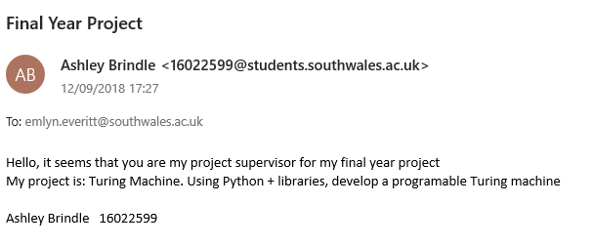

## figure2:

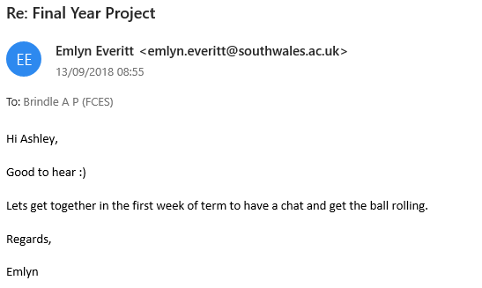

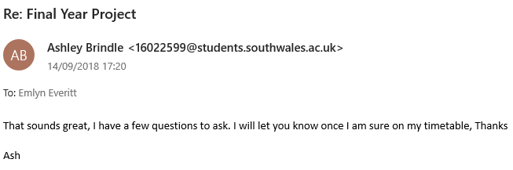

## figure3:

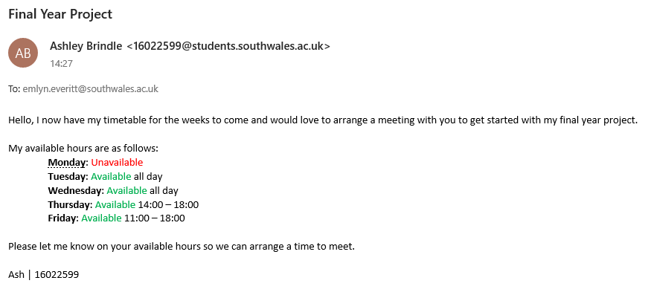

## figure4:

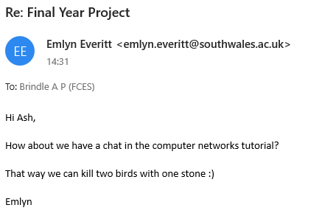

## figure5:

[*https://en.wikipedia.org/wiki/Turing_machine*](https://en.wikipedia.org/wiki/Turing_machine)

## figure6:

[*https://turingmachine.net.au/about.html*](https://turingmachine.net.au/about.html)

[*https://slideplayer.com/slide/1544381/*](https://slideplayer.com/slide/1544381/)

[*http://cse.csusb.edu/ykarant/courses/f2005/csci129/machines-and-metaphors/al-turing/depts/AI/alife/al-turin.html*](http://cse.csusb.edu/ykarant/courses/f2005/csci129/machines-and-metaphors/al-turing/depts/AI/alife/al-turin.html)

## figure7:

<https://github.com/wxWidgets/Phoenix/blob/master/README.rst>

<https://docs.wxwidgets.org/3.1/overview_python.html>

## figure8:

[*https://www.invensis.net/blog/it/benefits-of-python-over-other-programming-languages/*](https://www.invensis.net/blog/it/benefits-of-python-over-other-programming-languages/)

<https://medium.com/@mindfiresolutions.usa/advantages-and-disadvantages-of-python-programming-language-fd0b394f2121>

## figure9:

[*https://www.bbc.com/timelines/z8bgr82*](https://www.bbc.com/timelines/z8bgr82)

## figure10:

<https://medium.com/@calhoun137/alan-turings-universal-computing-machine-be69c052c6fd>

## figure11:

<https://blogs.scientificamerican.com/guest-blog/how-alan-turing-invented-the-computer-age/>

## figure12:

<https://en.wikiversity.org/wiki/Introduction_to_Turing_Machines>